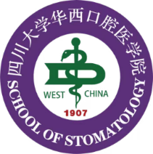
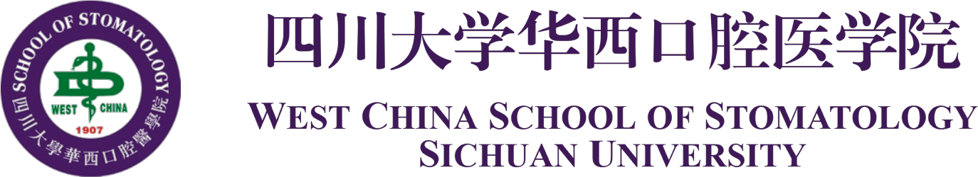

CERTIFICATE

December 1, 2023
Consulate General of United States of America
Chengdu, China

To Whom It May Concern,

This is to certify that Mr./Ms. 姓名拼音, a graduate student at Sichuan University, has been invited by 邀请方名称to visit the United States for 出访目的. He/ She will stay there for about 在外停留天数 days from 入境国外时间 to 出境国外时间.

The expenses may occur in this trip including international flight tickets, insurance, accommodations and the local transportation etc. will be covered by 资金来源名称（如：his/her supervisor's research fund/ Sichuan University）.

The name list is as follows:
Name | Date of Birth | Passport Number | Position
Zhang San | 01 September 1965 | PE1234567 | Graduate Student

Sichuan University has approved his/ her leave. Upon return to China, he/she will continue his/her studies at West China School of Stomatology, Sichuan University.

Your necessary support given to his/ her visa application will be sincerely and highly appreciated.

Thank you very much for your kind attention.

West China School of Stomatology, Sichuan University
Add: No.14, 3rd Section Of Ren Min Nan Rd. Chengdu, Sichuan 610041, China
Tel: 028-85553932
Fax: 028-85582167

